LOS TEMAS HAN SIDO ACTUALIZADOS DE ACUERDO A LAS NUEVAS CONDICIONES. SIGUEN SIENDO LOS MISMOS PERO AHORA LAS PRESENTACIONES SE HARÁN DE MANERA VIRTUAL SIGUIENDO LAS INDICACIONES DEL PLAN DE TRABAJO COMPARTIDO CON USTEDES. ADEMÁS, LOS NOVENOS HARÁN SU PROYECTO DE MANERA INDIVIDUAL. VER A CONTINUACIÓN…

Madre del Divino Pastor High School  English Department  B. A. Angie Rodriguez  7th grade | VIRTUAL ORAL PRESENTATION  Instructions  April 15th to April 30th
Topics to develop:
- Greetings  - Simple Present | - Spelling and numbers  - Personal Questions and Introductions

This is an individual exam. Students will be evaluated individually.
- Students will prepare an elaborated oral presentation.
- Students have been practicing and they have had these weeks as preparation for the exam.
- They will have to speak in English all the time.
- They are going talk about themselves. For example “Hello! My name is Angie Rodríguez. I live in Guadalupe. My phone number is… etc”
- AND, after that, they will show the picture of someone they like and introduce this person to the class. For example, “This is my friend Steven Jones. He lives in California. His phone number is… etc” These presentations must contain everything studied in class.
- The presentations could be 1 to 2 mins long.
- They have to talk about themselves and about another person. The information of this other person can be fake.
- Students SHOULD NOT READ during the presentation. They CANNOT SPEAK in Spanish during the presentation.
- This is a formal presentation. They should follow the online instructions sent this week.
- Students create their visuals and take pictures or attach an image.
- Vocabulary, Grammar, Pronunciation, Content and Communicative Skills will be graded.

Profesoraangiecmdp@gmail.com

Madre del Divino Pastor High School  English Department  B. A. Angie Rodriguez  8th grade | VIRTUAL ORAL PRESENTATION  Instructions  April 15th to April 30th  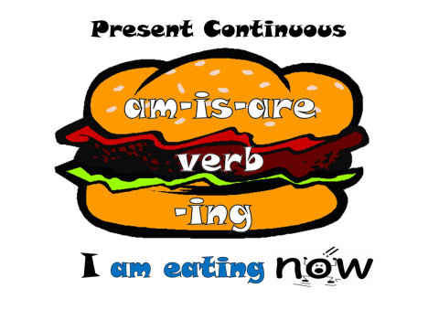
Topics to develop:
- Greetings  - Present Continuous  - Simple present | - Actions in Progress  - Habits  - Action Verbs

This is an individual exam. Students will be evaluated individually.
- Students will prepare an elaborated oral presentation.
- Students have been practicing and they have these weeks as preparation for the exam.
- They will have to speak in English all the time.
- They will have to visual aids to support their presentation.
- Students will choose one picture or several pictures of people performing different activities (It can be one person performing different actions OR different people doing things). And the picture of a famous artist or someone the student admires.
- Students will describe what is happening in the image, and will talk about a daily routine.
- This will be the structure of the presentation:
ºGreetings: Good morning! I am ….. I am going to talk about Actions in Progress
º 7 affirmative sentences in the Present Continuous: The old lady is feeding the cats. The cats are eating.
º3 negative sentences in the Present Continuous: The boy is not sleeping. Joe and Anna are not working.

º6 affirmative sentences in Simple Present Talking about Habits: I am going to talk about Robert Downey Jr. At 7:00 am, he runs. At 8:00 am, he goes to the Avengers set..
º4 negative sentences in Simple Present Talking about Habits: At 1:00 pm, he doesn’t have lunch, At 6:pm, He doesn’t watch Batman. TOTAL: 20 SENTENCES
ºThank you!
- You CANNOT REPEAT verbs. Every sentence must contain a different verb.
- Students SHOULD NOT READ during the presentation. Students CANNOT SPEAK in Spanish during the presentation.
- This is a formal presentation. They should follow the online instructions sent this week.
- Students can create their visuals and take pictures or attach an image.
- Vocabulary, Grammar, Pronunciation, Content and Communicative Skills will be graded.

Profesoraangiecmdp@gmail.com

Madre del Divino Pastor High School  English Department  B. A. Angie Rodriguez  9th grade | VIRTUAL ORAL PRESENTATION  Instructions  April 15th to April 30th

Topics to develop:
- Greetings  - The Past Tense  - Describing Activities in the past | - Talking about past events: Biographies  - Pronunciation of Regular e Irregular verbs in the past

This is a group oral exam. Students will be evaluated individually.
- Students will prepare an elaborated oral presentation.
- Students have been practicing and they have these weeks as preparation for the exam.
- They will have to speak in English all the time.
- Students will talk about an important WRITER (biography).
- The presentation must contain past tense sentences. One of the main purposes of this presentation is to evaluate the correct pronunciation of the regular and irregular verbs in the past. Try to include interesting information and fun facts to make the presentation more entertaining.
- Each student should last minimum one to two minutes speaking.
- Students SHOULD NOT READ during the presentation. Students CANNOT SPEAK in Spanish during the presentation.
- This is a formal presentation.
- This is a formal presentation. They should follow the online instructions sent this week.
- Students MUST create a PowerPoint slideshow.
- Vocabulary, Grammar, Pronunciation, Content and Communicative Skills will be graded.

Profesoraangiecmdp@gmail.com

